Fast Travel Map
A fast travel map is used to return to previous areas easily. However, you can’t return to those locations without locating the fast travel point and its corresponding map. This incentivizes people to look for treasure!

Create: Item
190 | Name | Map | Type | Key Item
 | Consum. | No | Scope | None
 | Occasion | Menu Screen | Effect | None

Create: Map
 | Name | Fast Travel | Display Name | Overworld Zone
 | Tileset | Overworld | Width | 50 or more
 | Scroll Type | No Loop | Height | 50 or more
 |  |  | Enc. Steps | 30

You will create a map item which can be interacted with to take you to the overworld map. Create a map that is used as your fast travel—tiles will be created to teleport you. The music and parallax can be anything you choose.
Next, make a Switch for each area you would like to fast travel to. For example, I would make one for the green area, the water area, the stone area, the desert area, the volcano area, and the snow area.

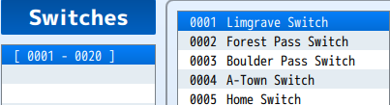
For this challenge, we will work with the grassy area, which we will call Limgrave, but you can call it anything. This will be called the Limgrave Switch.
You will also need to make a new Fast Travel Spot below for each new location you wish to add.

Create: Map Event Page 1
 | Name | Fast Travel Spot
 | Priority | Same As Player
 | Trigger | Player Touch
 | Switch | None

Create: Map Event Page 2
 | Name | Fast Travel Spot
 | Priority | Same As Player
 | Trigger | Player Touch
 | Switch | Limgrave Switch

Ensure both have walking, stepping, and direction fix enabled for the animations.

This map event will act as your fast travel location. With the player touching it, they’ll be transported to a new location.

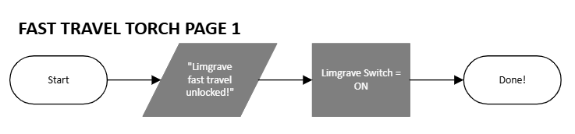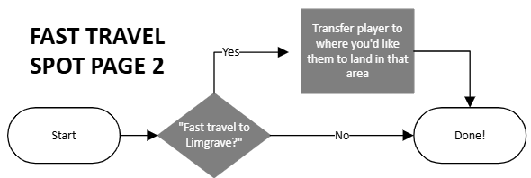
Create: Map Event Page 1
 | Name | Fast Travel Torch
 | Priority | Same As Player
 | Trigger | Action Button
 | Switch | None

Create: Map Event Page 2
 | Name | Fast Travel Torch
 | Priority | Same As Player
 | Trigger | Action Button
 | Switch | Limgrave Switch

Ensure animations are enabled for Page 2 ONLY.

These will be used to activate the fast travel locations. When they are unlocked, you will be able to fast travel there. You should put these in hard-to-find locations to make players want to explore to get back here. Now, when you unlock the torch, it’ll enable the fast travel in the fast travel map.

Make a Common Event that transfers the player to the fast travel map. Call it Fast Travel.

Make variables that save the player’s location in the common event made earlier before making them fast travel. Set three variables:

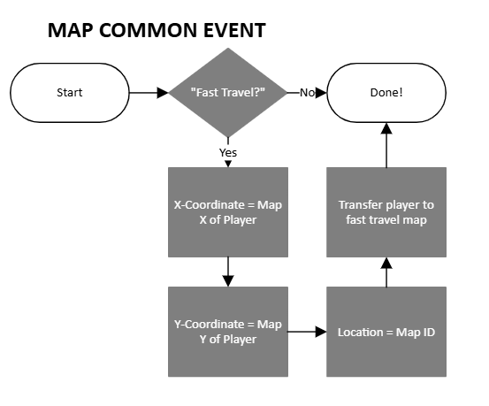
Create: Memory
Variables | X-Coordinate

Create: Memory
Variables | Y-Coordinate

Create: Memory
Variables | Location

Make these variables have these respective values in the common event:

- X-coordinate -> game data -> character -> player + map X
- Y-coordinate -> game data -> character -> player + map Y
- Location -> other -> map ID

These will be added to the common event.

Create: Map Event
 | Name | Fast Travel Return
 | Priority | Same As Player
 | Trigger | Player Touch
 | Switch | None

Ensure walking, stepping, and direction fix are enabled for the animations.

This map event will transfer the player back out of the fast travel if they choose no destination. Place it at the spot near where the player teleported to after using the map. When the player touches it, use transfer player to teleport them. The destination is designation with variables, ID being the location variable, X being the X-Coordinate variable, and Y being the Y-Coordinate variable.

You can add extra text for when these switches are not activated. For example:

Page 1 of Fast Travel Spot:
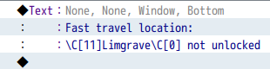

You should now have a working fast travel system! Test your code. How do the players get the map? Does the map teleport them correctly, there and back? Do locked travel spots work, as well as unlocking each of them?

